**Supplementary Material**

**Table S1. Index and Information Source**

|  |  |  |
| --- | --- | --- |
| **Index** | **Information Used** | **Information Source(s)** |
| Urban | 2012 Impervious Surface Status Map | * https://land.copernicus.eu/pan-european/high-resolution-layers/imperviousness |
| Agricultural | Number of fields per 1.5km radius circle divided by  Agricultural Area per 1.5km radius circle from 2015 Urban Atlas | * Google Maps * https://land.copernicus.eu/local/urban-atlas |
| Semi-Natural | Area of Herbaceous Vegetation Associations in 2015 Urban Atlas, area of habitats surveyed in Grasslands of Ireland Survey divided by the area of a 1.5km radius circle | * https://land.copernicus.eu/local/urban-atlas * https://www.npws.ie/maps-and-data/habitat-and-species-data |

**Table S2. Site Characteristics**

|  |  |  |  |  |  |  |  |
| --- | --- | --- | --- | --- | --- | --- | --- |
| **Site** | **Site ID** | **Landscape Type** | **Level** | **Urban Index** | **Semi Nat Index** | **Agric Index** | **Unified Index** |
| Dolphins Barn | 1 | Urban | High | 72 | 1 | 0 | 0.97 |
| JFK | 2 | Urban | High | 74 | 5 | 0 | 1.00 |
| North Strand | 3 | Urban | High | 70 | 2 | 0 | 0.95 |
| Goatstown | 4 | Urban | Medium | 43 | 5 | 0 | 0.58 |
| Killester | 5 | Urban | Medium | 46 | 0 | 0 | 0.62 |
| Templeogue | 6 | Urban | Medium | 42 | 2 | 0 | 0.57 |
| Finglas | 7 | Urban | Low | 15 | 3 | 2.08 | -0.12 |
| Malahide | 8 | Urban | Low | 12 | 6 | 1.75 | -0.11 |
| Powerstown | 9 | Urban | Low | 18 | 4 | 3 | -0.23 |
| Argillan Castle | 10 | Semi Natural | Semi Nat | 2 | 10 | 1.31 | -0.18 |
| Castletown | 11 | Semi Natural | Semi Nat | 16 | 11 | 2.45 | -0.17 |
| Newbridge Demesne | 12 | Semi Natural | Semi Nat | 7 | 17 | 2.28 | -0.26 |
| Balbriggan | 13 | Agricultural | Low | 0 | 5 | 2.61 | -0.41 |
| North Garristown | 14 | Agricultural | Low | 0 | 0 | 2.59 | -0.41 |
| West Dunboyne | 15 | Agricultural | Low | 1 | 0 | 3.44 | -0.53 |
| Cellbridge West | 16 | Agricultural | Medium | 1 | 1 | 3.86 | -0.59 |
| Garris/Bal | 17 | Agricultural | Medium | 1 | 0 | 4.39 | 0.98 |
| Leixlip | 18 | Agricultural | Medium | 1 | 2 | 4.01 | -0.62 |
| Ballyboughal | 19 | Agricultural | High | 2 | 0 | 5.02 | -0.76 |
| Clane | 20 | Agricultural | High | 1 | 1 | 5.07 | -0.78 |
| East Dunboyne | 21 | Agricultural | High | 0 | 0 | 6.37 | -1.00 |

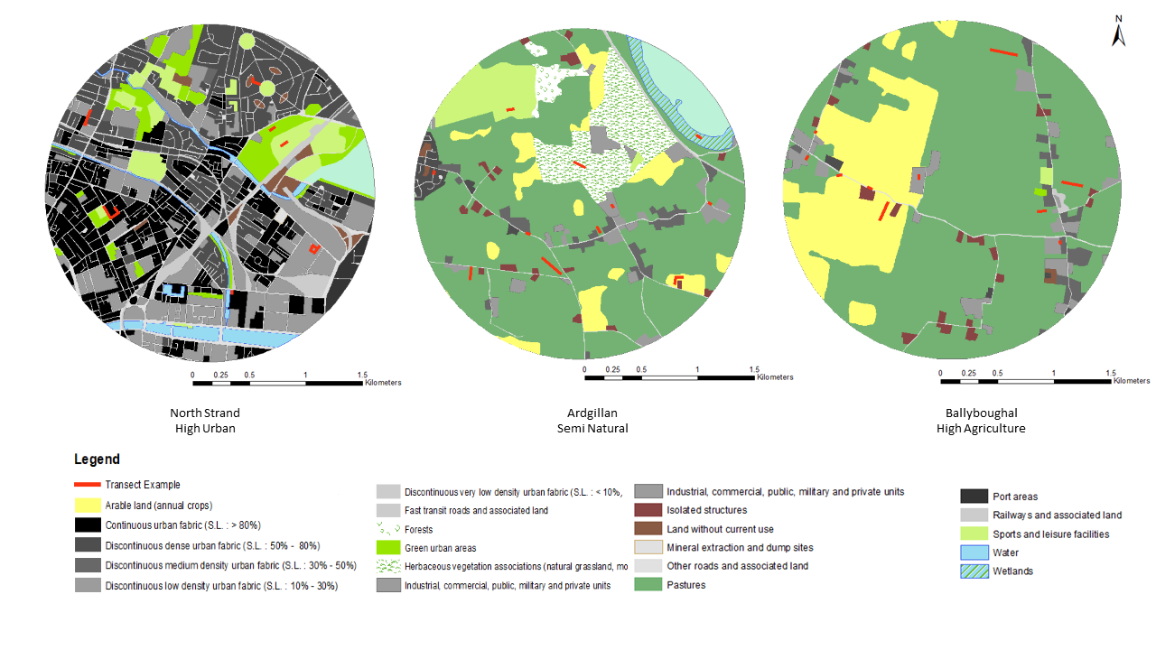

c

a

b

**Figure S1. Examples of transect locations within a) high urban, b) semi natural and c) high agricultural sites.** The 1.5km radius circle delimits the site. In each land cover type, randomly selected transect sections are shown in red; the length of transect walked in each land cover type was proportionate to the total amount of each land cover at that site.

**Table S3. Land cover areas and transect lengths for each landcover at the North Strand High Urban Site.**

|  |  |  |
| --- | --- | --- |
| **Habitat** | **Proportion of site** | **Total transect length (m)** |
| Continuous Urban Fabric | 0.21 | 229 |
| Discontinuous Dense Urban Fabric | 0.21 | 229 |
| Industrial, commercial, public, military | 0.21 | 229 |
| Other Roads and Associated Land | 0.11 | 120 |
| Green Urban Area | 0.07 | 76 |
| Sports and Leisure Facilities | 0.06 | 65 |
| Railways and Associated Land | 0.04 | 44 |

**Table S4. Floral Unit Definitions**

|  |  |
| --- | --- |
| **Floral Unit definition** | **Plant taxa** |
| Single flower | *Allium* spp, all Amaryllidaceae, all Apocynaceae, *Alstroemeria* spp., *Berberis* spp., all Boraginaceae, all Brassicaceae (except *Diplotaxis tenuifolia*), *Begonia semperflorens*, *Buxus sempervirens*, *Calysteiga sepium*, all Campanulaceae, all Caprifoliaceae (except *Scabiosa columbaria*), all Caryophyllaceae, *Chenopodium album*,all Convolvulaceae, *Cornus alba*, all Ericaceae, *Escallonia macrantha, Euphorbia exigua*, all Fabaceae (except *Trifolium* spp., *Vicia cracca, Vicia sepium*), all Geraniaceae, *Griselinia littoralis*, *Heuchera* spp., *Hycainthoides* spp., all Hydrangeaceae, *Hypericum* spp., all Iridaceae, *Lamium purpureum*, *Linum usitatissimum*, *Magnolia* spp., all Malvaceae, *Mentha × piperita*, *Narcissus* spp., *Nepeta* spp., all Oleaceae, all Onagraceae, all Orobanchaceae, *Oxalis debilis*, all Papaveraceae, all Plantaginaceae, all Polygonaceae, *Primula veris*,all Ranunculaceae, *Reseda luteola*, *Ribes sanguineum*, all Rosaceae (except *Filipendula ulmaria*, *Spiraea* spp.), *Rosmarinus officinalis*, *Scrophularia auriculate*, *Sedum* agg., all Solanaceae, *Stachys byzantina*, *Viburnum tinus*, *Viola odorata*. |
| Single capitulum | All Asteraceae (except *Achillea millefolium*), *Diplotaxis tenuifolia*, *Knautia arvensis, Scabiosa columbaria*. |
| Part of panicle | *Spiraea* spp. (apart from *Spiraea douglasii*). |
| Secondary umbel | All Apiaceae. |
| Single compound cyme | All Valerianaceae (apart from *Valerianella locusta*) |
| Single corymb | *Cornus* spp., *Sambucus nigra*, *Verbena bonariensis*. |
| Single cyme | *Euphorbia* spp. |
| Single panicle | *Buddleja* spp., *Spiraea douglasii*. |
| Single raceme | *Ajuga.reptans, Calluna vulgaris*, *Medicago* spp., *Prunus lusitanica*, *Trifolium* spp., *Vicia cracca, Vicia sepium*. |
| Single spike | *Callistemon* spp., *Lavandula* spp., *Rhus typhina*, *Sallix* spp, *Salvia* spp. |
| Single thyrse | *Ceanothus* spp. |

**Figure S2.** Rarefaction curves of the whole dataset for A) the number of unique interactions (862), B) the number of unique pollinator species (86) and C) the number of unique plant species (192).

A

B

C

Sampling coverage was calculated using hill numbers from the iNEXT package in R (Hsieh, Ma & Chao 2019).

## Community Dissimilarity

Figure S5. Similarity in the composition of plants, pollinators and their interactions networks as a function of spatial (a-c) and environmental distance (d-f). Bray-Curtis beta diversity index used to calculate plant and pollinator pairwise beta diversity results in a very similar pattern to that created using the hill numbers and setting q=1. To reduce the effect of differing alpha diversities, we calculated z-scores as a measure of deviation from randomness. *z*-scores were given as (*β*emperical − Inline Formula)/SDresampled, where *β*emperical is the empirical similarity between two networks, and Inline Formula and SDresampled are the mean and standard deviation of the similarities when performing 1000 random assortments of species and interactions, respectively. Positive and negative *z*-scores signify higher and lower similarity, respectively, than expected from random distributions of species and interactions. Filled circles indicate that a given empirical pairwise comparison differed significantly from the resampled values, and grey dashed lines mark the boundary between 1.96 and −1.96.

The bee community composition does not significantly respond to geographical distance (Mantel test with 999 permutations: *r*M = 0.0829, *p* = 0.206) or environmental dissimilarity (Mantel test with 999 permutations: *r*M = 0.0504, *p* = 0.336) (Figure S6 a-b). However, the hoverfly community composition does significantly respond to geographical distance (Mantel test with 999 permutations: *r*M = 0.148, *p* = 0.039) but not to environmental dissimilarity (Mantel test with 999 permutations: *r*M = 0.037, *p* = 0.346) (Figure S6 c-d).

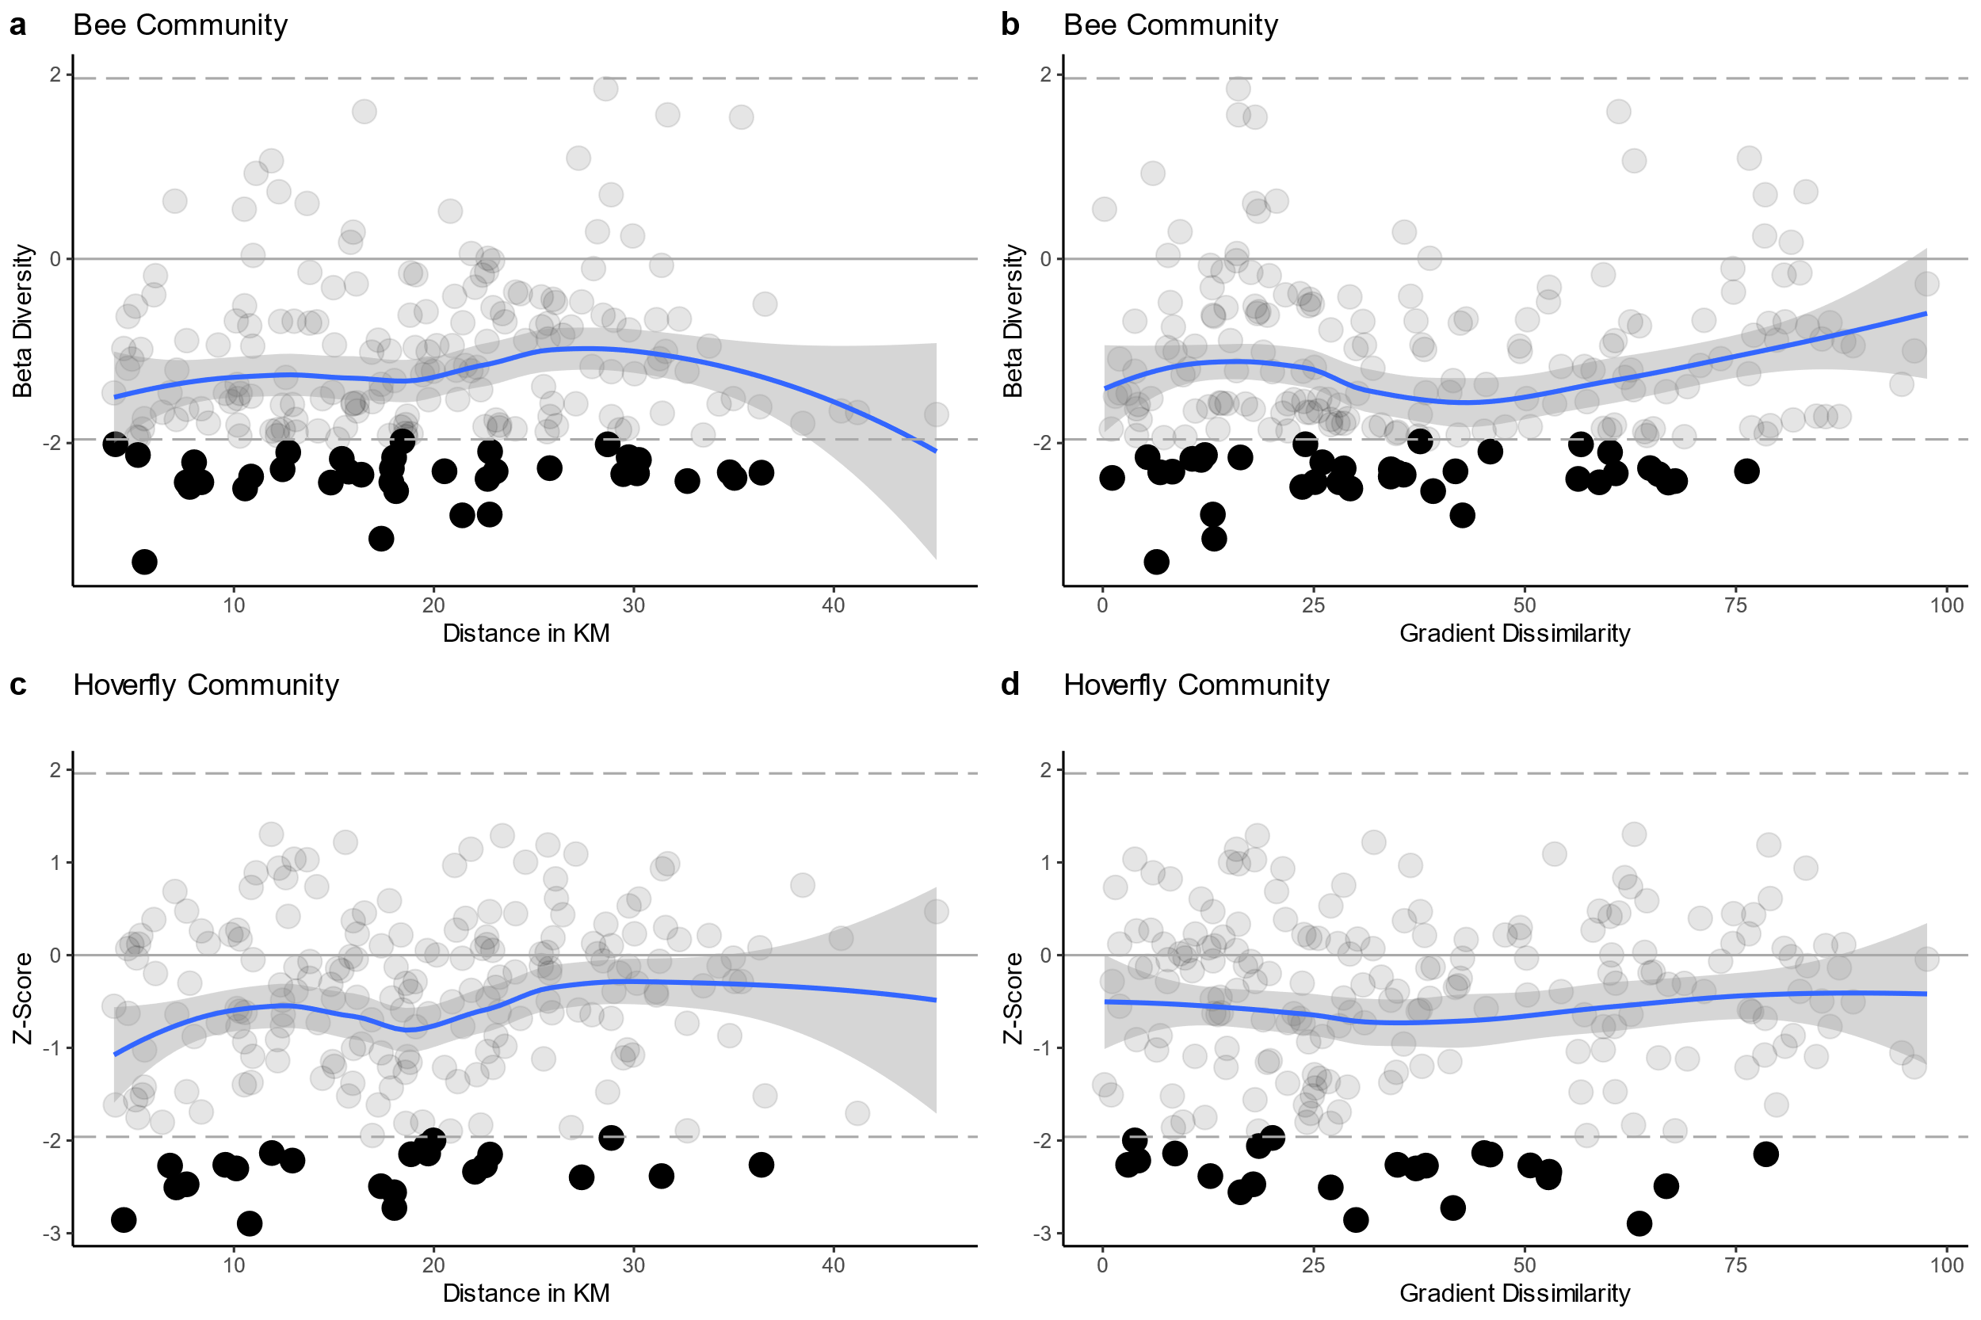

Figure S6. Bee and Hoverfly Community Dissimilarity. Sorensen community dissimilarity shows that the bee community responds to neither spatial distance or environmental dissimilarity, while the hoverfly community is structured by spatial distance but not gradient dissimilarity.

The native plant community (74 native species) composition significantly responds to both geographical distance (Mantel test with 999 permutations: *r*M = 0.2643, *p* = 0.002), and anthropogenic environmental dissimilarity (Mantel test with 999 permutations: *r*M = 0.3486, *p* = 0.001) (Figure S7 a-b), while the introduced plant community (92 introduced species) composition did not significantly respond to geographical distance (Mantel test with 999 permutations: *r*M = 0.031, *p* = 0.367) but did respond to anthropogenic environmental dissimilarity (Mantel test with 999 permutations: *r*M = 0.1989 *p* = 0.027) (Figure S7 c-d).

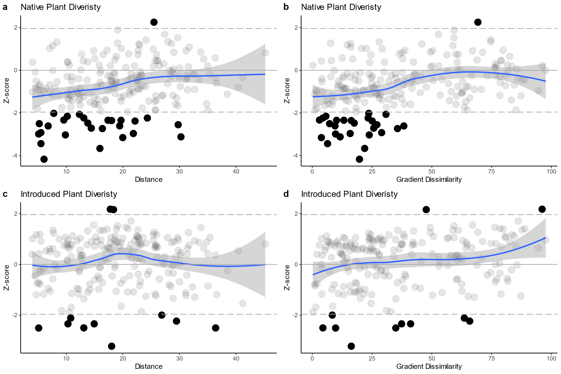

Figure S7. Native (a-b) and Introduced (c-d) Plant Community Dissimilarity. Sorensen community dissimilarity shows that the native plant community responds to both spatial distance and the environmental gradient, while the introduced plant community shows only responds to environmental gradient.

### Variation Partitioning

Figure S8. Variation partitioning of the plant community (A), pollinator community (B) and interaction networks (C - F). The overlap of the Venn diagram accounts for spatially structured environmental variables, while the non-overlap areas account for the pure environmental and spatial partition. Variation partitioning was carried out for networks including just the environmental and spatial datasets (C), adding the plant beta diversity dataset (D), adding the pollinator beta diversity data set (E) and adding both the plant and pollinator beta diversity datasets (F). Blank areas indicate that no variation was accounted for by that partition. Residual values are the total unexplained variation. Presence absence community and interaction datasets were used.

# Drivers of interaction turnover

Table S5. Results of two-tailed Mantel tests for effect of spatial distance and environmental dissimilarity on interaction turnover, rewiring, plant driven, pollinator and plant+pollinator (Both_turn) driven turnover. Significant results highlighted in bold. Null hypothesis r = 0.

|  |  |  |  |  |
| --- | --- | --- | --- | --- |
|  | **Spatial Distance** | | **Environmental Dissimilarity** | |
| **Metric** | **Mantel Statistic** | **Significance** | **Mantel Statistic** | **Significance** |
| Rewire | -0.0849888 | 0.413 | **-0.5632732** | **0.001** |
| Turnover | 0.0849888 | 0.397 | **0.5632732** | **0.001** |
| Pol_turn | 0.0488109 | 0.633 | **-0.4723835** | **0.001** |
| Plant_turn | -0.1494574 | 0.170 | 0.2295144 | 0.060 |
| Both_turn | 0.1274168 | 0.235 | **0.2256112** | **0.035** |

Using z-score measures to compare the empirically measured contributions of the drivers of interaction turnover to null expectations resulted in some different patterns and additional information. The null expectations attempt to remove the effect of environmental filtering and dispersal limitation by assigning species and interactions to sites based purely on observed occurrences, i.e. a species found at 50% of sites has a 50% probability of occurring at any site regardless of environmental conditions or spatial distance between sites. The z-scores reveal that species-driven interaction turnover occurs less frequently than expected under such null assumptions while the rewiring occurs more than expected. Species driven interaction turnover contributes more than 80% to interaction turnover (Figure 4), and so for the z-scores to indicate that we should expect it to contribute more under random assortment of species means that a filtering process that results in communities more similar than expected is taking place. The strong correlation of species-driven interaction turnover with environmental dissimilarity strongly suggests that the anthropogenic gradient exerts the filtering force (Table S6), such that communities in similar landscapes are more similar than expected and results in less species-driven interaction turnover than expected under null assumptions. Thus, the data suggest that the anthropogenic landscapes strongly structure the drivers of interaction turnover.

At low environmental dissimilarity, neither the contribution of plant nor pollinator driven turnover to species driven turnover are different than expected from the null distribution, yet both plant and pollinator driven turnover tend to exceed null model expectations at high environmental dissimilarity. More plant turnover is occurring than expected passed the midway point of environmental dissimilarity, correlating with a site comparison between landscapes (agricultural vs urban comparison or *vice versa*) rather than within landscapes (agricultural vs agricultural comparison of *vice versa*), while simultaneously less pollinator driven turnover is occurring than expected. Given there is no change in the pollinator community composition over the environmental dissimilarity gradient (Figure 3), the only reason that the species driven turnover contributions change across the gradient is due to the changing plant community. Thus, the filtering process of the plant community by the anthropogenic environment causes the contributions of the drivers of network difference to shift in response

Figure S9. The z-score measures of the contribution of species-driven interaction turnover (yellow points and yellow line) or rewiring (purple points and purple line) to total interaction turnover plotted in relation to geographical distance (a) or the environmental dissimilarity (d) between paired networks. Z-score measures of the proportion of the species-driven interaction turnover that can be ascribed as pollinator-driven (blue points and blue line) and plant-driven (orange points and orange line) as a function of spatial distance (b) or environmental dissimilarity (e). Z-score measures of the proportion of species-driven interaction turnover that is caused by a combined turnover of both plants and pollinators (pollinator + plant-driven) in relation to geographical distance (c) and environmental dissimilarity (f). Dashed lines indicate ±1.96 z-score with any points exceeding 1.96 or below -1.96 indicating that the site comparison in question falls outside the null model expectations. Note the change of scale between graphs.

Table S6. Results of two tailed Mantel tests for effect of spatial distance and environmental dissimilarity on z-score measures of species-driven interaction turnover, rewiring, plant driven, pollinator and plant+pollinator (Both_turn) driven turnover. Significant results highlighted in bold. Null hypothesis r = 0.

|  |  |  |  |  |
| --- | --- | --- | --- | --- |
|  | **Spatial Distance** | | **Environmental Dissimilarity** | |
| **Metric** | **Mantel Statistic** | **Significance** | **Mantel Statistic** | **Significance** |
| Rewire | -0.1295383 | 0.188 | **-0.4581622** | **0.001** |
| Turnover | 0.1295383 | 0.180 | **0.4581622** | **0.001** |
| Pol_turn | 0.0789561 | 0.469 | **-0.4066695** | **0.001** |
| Plant_turn | -0.1893076 | 0.076 | **0.2713031** | **0.023** |
| Both_turn | **0.2330795** | **0.021** | 0.2002743 | 0.079 |

# Prediction of Interaction Turnover

For each of the drivers of interaction turnover (rewiring and species driven turnover decomposed into pollinator driven turnover, plant driven turnover and both plant and pollinator driven turnover) we build binomial generalised mixed effects regression models to predict when an interaction turns over or stays constant. The purpose is to twofold: 1) to compare and contrast what predictor variables are correlated with each driver of interaction turnover and 2) to assess the importance of these predictor variables by carrying out a prediction exercise. The random effects in the GLMMs are the site pair being compared, the pollinator species and the plant species involved in the interaction. To assess the importance of the fixed predictor variables in predicting when an interaction turns over, we split the data into training and test datasets and calculate the area under the receiver operating curve (AUC) in a binomial GLMM containing the predictors variables with a null model containing just the random effects. The receiver operating curve is created by plotting the true positive rate (TPR) against the false positive rate (FPR) at various threshold settings. For a given threshold value, the closer the corresponding point in the ROC space is to the upper left angle (FPR = 0, TPR = 1), the more accurate the model can be considered. Thus, an indication of the overall model performance is given by the Area Under Curve AUC index (Hanley and McNeil, 1982), computed by numerical integration of the curve f = TPR(FPR).

## Model Construction

The random effect variables first chosen for each driver of interaction turnover. Where possible the plant species, pollinator species and site pair involved in the interaction turnover were used as random effects. This was possible for the plant driven interaction turnover (*Ipla*) and plant and pollinator driven interaction turnover (*Ipol+pla*) as there was enough data to create a training and test dataset with the same species and site pairs to allow prediction performance to be estimated. Where data was limited a compromise was reached between ensuring a large enough training and test dataset to allow assessment of predictive performance and including the random effects that contained the most variance. When predicting rewiring (*Irewire*), the pollinator and plant species were used as random effects, but site pair was not included as it contained the least variance and significantly reduced the size of the training and test datasets when included. For pollinator driven interaction turnover (*Ipol*), only pollinator species was used as the random effect.

Once the random effects had been chosen, the fixed effects were chosen based on model selection procedure using AIC. Many combinations of the fixed effects were fit and the AIC compared, with the lowest AIC model being chosen as the best fitting model. Average interaction frequency and relative abundance of the plant species could only be used as fixed effects for rewiring and pollinator driven interaction turnover.

## Model Validation

Using the DHARMa (Hartig 2020) package, each binomial model was checked for overdispersion and heteroscedasticity. Most binomial GLMMs were over dispersed and heteroscedastic with respect the discretised predictor, an effect that could only be corrected for by introducing an Observation Level Random Effect (OLRE). However, the well behaved models with an OLRE cannot be used to predict outside of the training data used, and as the aim was to assess the improved performance in prediction of turnover or consistency, many of the binomial GLMMs presented below suffer from overdispersion and heteroscedasticity. The cause of the overdispersion and heteroscedasticity is likely an unmeasured variable.

## Rewiring

Rewiring accounts for ~20% of the difference observed between networks and so is a substantial contributor to network beta diversity (Figure 4 *a* & *d*). Rewiring is defined as an interaction turnover among a site pair where the interacting species are present at both sites but only interact at one site. As such, each row in the data frame (N = 45266) specifies the site pair, the pollinator species and the plant species involved in the interaction with a response variable of whether or not the interaction rewired (1) or was conserved (0) between that site pair. Only 2257 instances of interaction constancy were observed, of which 1168 were placed in the training data set as the training zeros. 942 instances of interaction turnover were sampled from the data set, ensuring the same plant and pollinator species were sampled as those sampled in the training zeros, to create the training ones. Combining the training ones and training zeros resulted in the training data set (N = 2110). A test data set (N = 2084) was created using the same procedure and contained 1089 instances of interaction constancy and 955 instances of rewiring.

A model of form:

was fit to the training data (see Table S6 for model summaries) and was then used to predict when an interaction would rewire or stay consistent in the test data, with an AUC score of 0.97 indicating very good prediction performance. However, when the random effects model was tested, i.e a model of the form:

,an AUC score of 0.93 was obtained indicating that much of the predictive performance of the model including the fixed effects was due to the inclusion of the pollinator and plant species as random effects. Additionally, a binomial glm of the form:

was fit to explore the predictive performance of the covariates in the absence of the random effects, resulting in an AUC score of 0.83. The reasonable predictive performance of the glm indicates that the covariates in question are useful for predicting when an interaction will rewire or stay consistent, yet this predictive performance is lower compared to the random effects model of the pollinator and plant species indicating that much of the variance in whether an interaction will rewire or not is dependent on the species in question and less so on the surrounding environment.

Table S6. Model summaries and parameter estimates for the fixed and random effects binomial GLMM predicting rewiring. Significance level is indicated by * (P<0.05), ** (P<0.01) and *** (P<0.001)

|  |  |  |  |
| --- | --- | --- | --- |
| Fixed Effects | Estimate | SE | z-score |
| Average Interaction Frequency *** | -0.4565 | 0.453 | 5.161 |
| Relative Abundance *** | 0.5412 | 0.1505 | 3.597 |
| Gradient Dissimilarity ** | 0.2550 | 0.0896 | 2.842 |
| AgIndex Average*** | 1.2484 | 0.1071 | 11.651 |
| Impervious Average | -0.1232 | 0.1583 | -0.778 |
| Plant Origin*** | -2.2943 | 0.4742 | -4.838 |
|  |  |  |  |
| Random Effects | Variance | Standard Deviation |  |
| Pollinator Species | 2.913 | 1.707 |  |
| Plant Species | 1.806 | 1.344 |  |

Table S7. Model summaries and parameter estimates for the binomial GLM predicting rewiring. Significance level is indicated by * (P<0.05), ** (P<0.01) and *** (P<0.001)

|  |  |  |  |
| --- | --- | --- | --- |
| Fixed Effects | Estimate | SE | z-score |
| Average Interaction Frequency *** | -0.7247 | 0.0684 | **-**10.599 |
| Relative Abundance *** | 0.6291 | 0.1137 | 5.532 |
| Gradient Dissimilarity * | 0.1347 | 0.0597 | 2.257 |
| AgIndex Average*** | 0.5727 | 0.0701 | 8.167 |
| Impervious Average* | 0.2254 | 0.0971 | 2.322 |
| Plant Origin*** | -1.1888 | 0.1315 | -9.038 |
|  |  |  |  |

Table S8. Confusion matrix for the GLM, mixed effects model and the random effects model including only species identity for interaction rewiring. Zeros are instances of interaction constancy and ones are instances of interaction rewiring.

|  |  |  |  |  |  |  |
| --- | --- | --- | --- | --- | --- | --- |
|  | **GLM** | | **Mixed Effects** | | **Species Identity** | |
|  | **0** | **1** | **0** | **1** | **0** | **1** |
| **0** | 846 | 148 | 1018 | 89 | 1089 | 245 |
| **1** | 243 | 755 | 71 | 814 | 0 | 658 |

## Species Driven Interaction Turnover

Species driven interaction turnover accounts for ~80% of the difference observed between networks and so is the major contributor to network beta diversity (Figure 4 *a* & *d*). Yet, species driven interaction turnover can be decomposed into pollinator driven, plant driven, and plant and pollinator driven interaction turnover (Figure 2) and so each component of species driven interaction turnover is treated separately.

### Pollinator Driven Interaction Turnover

Pollinator driven interaction turnover accounts for ~10% of the difference observed between networks and so is a minor contributor to network beta diversity (Figure 4 *b* & *e*). Pollinator driven interaction turnover is defined as an interaction turnover among a site pair where the interacting plant species is present at both sites, but the pollinator species is present at only one site. As such, each row in the data frame (N = 127965) specifies a site pair where an interaction between a plant and a pollinator was observed in at least one of the sites, the pollinator species and the plant species involved in the interaction, and the response variable of whether or not the pollinator species is present at both sites (1) or was absent at one site (0). 14479 instances of pollinator driven turnover (1) were observed, of which 2083 were placed in the training data set as the training ones. 2181 instances of pollinator constancy (0) were sampled from the data set, ensuring the same plant and pollinator species were sampled as those sampled in the training zeros, to create the training zeros. Combining the training ones and training zeros resulted in the training data set (N = 4264). A test data set (N = 21942) was created using the same procedure and contained 11633 instances of pollinator constancy and 10309 instances of pollinator turnover.

A model of form:

was fit to the training data (see Table S8 for model summaries) and was then used to predict when an interaction would turnover or stay consistent in the test data, with an AUC score of 0.826 indicating reasonably good prediction performance. However, when the random effects model was tested, i.e a model of the form:

,an AUC score of 0.8276 was obtained indicating that all of the predictive performance of the model including the fixed effects was due to the inclusion of the pollinator species as a random effect. Additionally, a binomial glm of the form:

was fit to explore the predictive performance of the covariates in the absence of the random effect, resulting in an AUC score of 0.62. The relatively poor predictive performance of the glm indicates that the covariates in question are not very useful for predicting when an interaction will turnover due to pollinator driven turnover. The reasonable predictive performance of the model including only the pollinator species random effect indicates that much of the variance in whether an interaction will turnover due to pollinator driven turnover is dependent on the pollinator species in question and less so on the surrounding environment or interaction strength.

Table S9. Model summaries and parameter estimates for the fixed and random effects binomial GLMM predicting pollinator driven interaction turnover. Significance level is indicated by * (P<0.05), ** (P<0.01) and *** (P<0.001)

|  |  |  |  |
| --- | --- | --- | --- |
| Fixed Effects | Estimate | SE | z-score |
| Average Interaction Frequency *** | -0.6371 | 0.1044 | -6.102 |
| Gradient Dissimilarity *** | 0.2397 | 0.0697 | 3.438 |
| Impervious Average*** | -0.6487 | 0.1181 | -5.492 |
| AgIndex Average | -0.1061 | 0.0945 | -1.123 |
| Impervious * AgIndex*** | -0.4079 | 0.0694 | -5.880 |
|  |  |  |  |
| Random Effects | Variance | Standard Deviation |  |
| Pollinator Species | 12.21 | 3.495 |  |

Table S10. Confusion matrix for the GLM, mixed effects model and the random effects model including only species identity for pollinator-driven species turnover. Zeros are instances of interaction constancy and ones are instances of interaction turnover.

|  |  |  |  |  |  |  |
| --- | --- | --- | --- | --- | --- | --- |
|  | **GLM** | | **Mixed Effects** | | **Species Identity** | |
|  | **0** | **1** | **0** | **1** | **0** | **1** |
| **0** | 9382 | 6351 | 10539 | 3536 | 9975 | 3030 |
| **1** | 3418 | 4685 | 2261 | 7500 | 2825 | 8006 |

### Plant Driven Interaction Turnover

Plant driven interaction turnover accounts for ~55% of the difference observed between networks and so is the major contributor to network beta diversity (Figure 4 *b* & *e*). Plant driven interaction turnover is defined as an interaction turnover among a site pair where the interacting pollinator species is present at both sites, but the plant species is present at only one site. As such, each row in the data frame (N = 127965) specifies a site pair where an interaction between a plant and a pollinator was observed in at least one of the sites, the pollinator species and the plant species involved in the interaction, and the response variable of whether or not the plant species is present at both sites (1) or was absent at one site (0). 62518 instances of plant driven turnover (1) were observed, of which 9267 were placed in the training data set as the training ones. 9957 instances of plant constancy (0) were sampled from the data set, ensuring that the plant and pollinator species and the site pairs that were sampled were the same as those sampled in the training zeros, to create the training zeros. Combining the training ones and training zeros resulted in the training data set (N = 19244). A test data set (N = 12761) was created using the same procedure and contained 6514 instances of plant constancy and 6247 instances of plant turnover.

A model of form:

was fit to the training data (see Table S9 for model summaries) and was then used to predict when an interaction would turnover or stay consistent in the test data, with an AUC score of 0.913 indicating very good prediction performance. However, when the random effects model was tested, i.e a model of the form:

, an AUC score of 0.9132 was obtained indicating that all of the predictive performance of the model including the fixed effects was due to the inclusion of the plant species as a random effect. Additionally, a binomial glm of the form:

was fit to explore the predictive performance of the covariates in the absence of the random effect, resulting in an AUC score of 0.648. The relatively poor predictive performance of the glm indicates that the covariates in question are not very useful for predicting when an interaction will turnover due to plant driven turnover. The very good predictive performance of the model including only the plant species random effect indicates that much of the variance in whether an interaction will turnover due to plant driven turnover is dependent on the plant species in question and less so on the surrounding environment.

Table S11. Model summaries and parameter estimates for the fixed and random effects binomial GLMM predicting pollinator driven interaction turnover. Significance level is indicated by * (P<0.05), ** (P<0.01) and *** (P<0.001)

|  |  |  |  |
| --- | --- | --- | --- |
| Fixed Effects | Estimate | SE | z-score |
| Gradient Dissimilarity *** | 0.9075 | 0.2090 | 4.341 |
| Impervious Average | -0.1984 | 0.3326 | -0.593 |
| AgIndex Average | -0.0322 | 0.2815 | -0.114 |
| Plant Origin | -0.3087 | 0.6187 | -0.499 |
| Impervious*AgIndex* | -0.3925 | 0.1892 | -2.074 |
|  |  |  |  |
| Random Effects | Variance | Standard Deviation |  |
| Pollinator Species | 4.435 | 2.085 |  |
| Plant Species | 2.267 | 1.506 |  |
| Site Pair | 3.979 | 1.995 |  |

Table S12. Confusion matrix for the GLM, mixed effects model and the random effects model including only species identity for plant-driven species turnover. Zeros are instances of interaction constancy and ones are instances of interaction turnover.

|  |  |  |  |  |  |  |
| --- | --- | --- | --- | --- | --- | --- |
|  | **GLM** | | **Mixed Effects** | | **Species Identity** | |
|  | **0** | **1** | **0** | **1** | **0** | **1** |
| **0** | 3677 | 2111 | 6367 | 1498 | 6362 | 1497 |
| **1** | 3519 | 5015 | 829 | 5628 | 834 | 5629 |

### Plant and Pollinator Driven Interaction Turnover

Plant and Pollinator driven interaction turnover accounts for ~15% of the difference observed between networks and so is the major contributor to network beta diversity (Figure 4 *c* & *f*). Plant and pollinator driven interaction turnover is defined as an interaction turnover among a site pair where the interacting pollinator and plant species is present at one site but are both absent from the other site. As such, each row in the data frame (N = 127965) specifies a site pair where an interaction between a plant and a pollinator was observed in one of the sites, the pollinator species and the plant species involved in the interaction, and the response variable of whether or not both the plant and pollinator species is present at both sites (1) or absent at one site (0). 12045 instances of plant and pollinator driven turnover (1) were observed, of which 1394 were placed in the training data set as the training ones. 1185 instances of plant and pollinator constancy (0) were sampled from the data set, ensuring that the plant and pollinator species and the site pairs that were sampled were the same as those sampled in the training zeros, to create the training ones. Combining the training ones and training zeros resulted in the training data set (N = 2759). A test data set (N = 5692) was created using the same procedure and contained 2827 instances of plant and pollinator constancy and 2865 instances of plant and pollinator driven turnover.

A model of form:

was fit to the training data (see Table S10 for model summaries) and was then used to predict when an interaction would turnover or stay consistent in the test data, with an AUC score of 0.864 indicating reasonably good prediction performance. However, when the random effects model was tested, i.e a model of the form:

, an AUC score of 0.866 was obtained indicating that all of the predictive performance of the model including the fixed effects was due to the inclusion of the plant and pollinator species as random effects. Additionally, a binomial glm of the form:

was fit to explore the predictive performance of the covariates in the absence of the random effect, resulting in an AUC score of 0.5793. The poor predictive performance of the glm indicates that the covariates in question are not very useful for predicting when an interaction will turnover due to plant and pollinator driven turnover. The reasonable predictive performance of the model including only the plant and pollinator species random effects indicates that much of the variance in whether an interaction will turnover due to plant and pollinator driven turnover is dependent on the plant and pollinator species in question and less so on the surrounding environment.

Table S13. Model summaries and parameter estimates for the fixed and random effects binomial GLMM predicting pollinator driven interaction turnover. Significance level is indicated by * (P<0.05), ** (P<0.01) and *** (P<0.001)

|  |  |  |  |
| --- | --- | --- | --- |
| Fixed Effects | Estimate | SE | z-score |
| Distance between Sites . | 0.3921 | 0.2363 | 1.659 |
| Impervious Average | -0.1479 | 0.3607 | -0.404 |
| AgIndex Average | -0.2418 | 0.3156 | 0.766 |
| Impervious*AgIndex* | -0.5501 | 0.2164 | 0.011 |
|  |  |  |  |
| Random Effects | Variance | Standard Deviation |  |
| Pollinator Species | 86.39 | 9.295 |  |
| Plant Species | 48.92 | 6.884 |  |
| Site Pair | 4.796 | 2.190 |  |

Table S14. Confusion matrix for the GLM, mixed effects model and the random effects model including only species identity for plant+pollinator-driven species turnover. Zeros are instances of interaction constancy and ones are instances of interaction turnover.

|  |  |  |  |  |  |  |
| --- | --- | --- | --- | --- | --- | --- |
|  | **GLM** | | **Mixed Effects** | | **Species Identity** | |
|  | **0** | **1** | **0** | **1** | **0** | **1** |
| **0** | 2136 | 1720 | 2286 | 415 | 2360 | 470 |
| **1** | 1051 | 1401 | 901 | 2706 | 827 | 2651 |

# References

Hsieh, T. C., Ma K. H. and Chao A. (2019). iNEXT: iNterpolation and EXTrapolation for species diversity. R package version 2.0.19 URL: <http://chao.stat.nthu.edu.tw/blog/software-download/>

Hartig F. (2020). DHARMa: Residual Diagnostics for Hierarchical (Multi-Level / Mixed) Regression Models. R package version 0.3.3.0. <http://florianhartig.github.io/DHARMa/>

Hanley, J. A., & McNeil, B. J. (1982). The meaning and use of the area under a receiver operating characteristic (ROC) curve. *Radiology*, *143*(1), 29-36.